HELLENIC REPUBLIC |  | FACULTY OF HEALTH SCIENCES  DEPARTMENT OF MEDICINE  MASTER OF SCIENCE  “Application of endoscopic surgical techniques in gynecology”
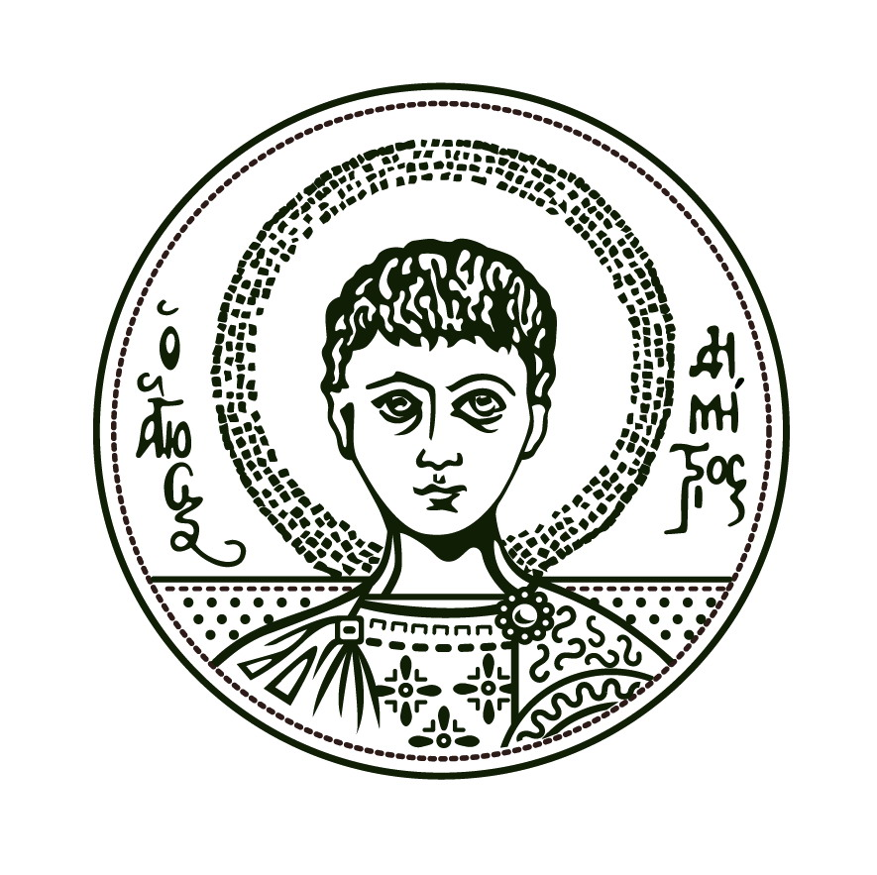 |  | Director: A. Daniilidis, Associated Professor
ARISTOTLE UNIVERSITY Of  THESSALONIKI |  | Information:  e-mail: pmsi.auth@gmail.com

Thessaloniki, / / 2021

Application form

Please, accept my application form for the MSc Program in Medical Research Methodology.

Name

Surname

Father name
and surname
Mother name
and surname
Nationality

Address

Zip code

City

Phone
E-mail

Tax Identification number (ΑΦΜ)
Financing body
(ΔΟΥ)
I hold a bachelor / MSc / PhD / other degree(s) in/from | eg: Bachelor in Medicine, Aristotle University of Thessaloniki

I agree to abide by the MSc Program regulations | YES □ NO □

Attachments

1. | Bachelor / MSc / PhD / other degree(s).
2. | Recognition Degree from ΔΟΑΤΑΠ (if needed)
3. | Academic transcript with a list of all grades received of undergraduate studies
3. | Recently updated Curriculum Vitae, with details about education, training, work experience, academic publications and academic achievements
4. | Proof of competency in English language.
5. | Photocopy of personal ID or passport with personal details or an equivalent state-issued document
6. | Letter of Intent
7. | Other documents if available (proofs of profession or research experience, reference letters, etc)

